**Assignment 3: Hi-fi Prototype and Usage Testing**

**Group Members: Clinton Muldoon, Ankit Shaji and Marion Veloria**

**Prototype Description: 1500 words**

**Scenario -**

A Group of university students are using our new share file system for their assignment.In the previous system they used, there was an privacy/security issue,ie 2 week earlier one of their group member accidently deleted one of the important files for their project.They were also unable to figure out who had accidently deleted the file.Now in the current system a user is trying to share a file without having any of these issues.

**1.** **The need for comfort from progress being on track -**

**Use Case elaboration -**

There is a lot of stress on the students while doing a group assignment; this can be due to the multiple tasks everyone in the group has to collaborate on. Some of this anxiety comes from the lack of ability to track the projects progress in connection to time left for completion. This is not just letting the user know when things need to be completed but also for the user to feel comfort in knowing progress ison the way as well as to reflect on why particular sections are taking longer time and if there is a need for a structural change for the project.

The first use case is the requirement of being able to visually see a due date for each section as well as the whole project. The due dates can be self-created for each section of the project so that the group members working on that section of the project know when their section is required to be completed. This is done due to the need for the completion of one section before the other, thus making the group work more efficiently. The showing of the due dates help the user be more aware of the coming up deadline so that they are always aware of how much effect needs to be put in and when, knowing if they are behind or ahead of schedule gives the group an idea of what needs to have higher priority.

This relates to the scenario as the members in the group have to be allocated specific work and the group members all need to be aware of the due dates coming up.

**Screenshots of website**  –

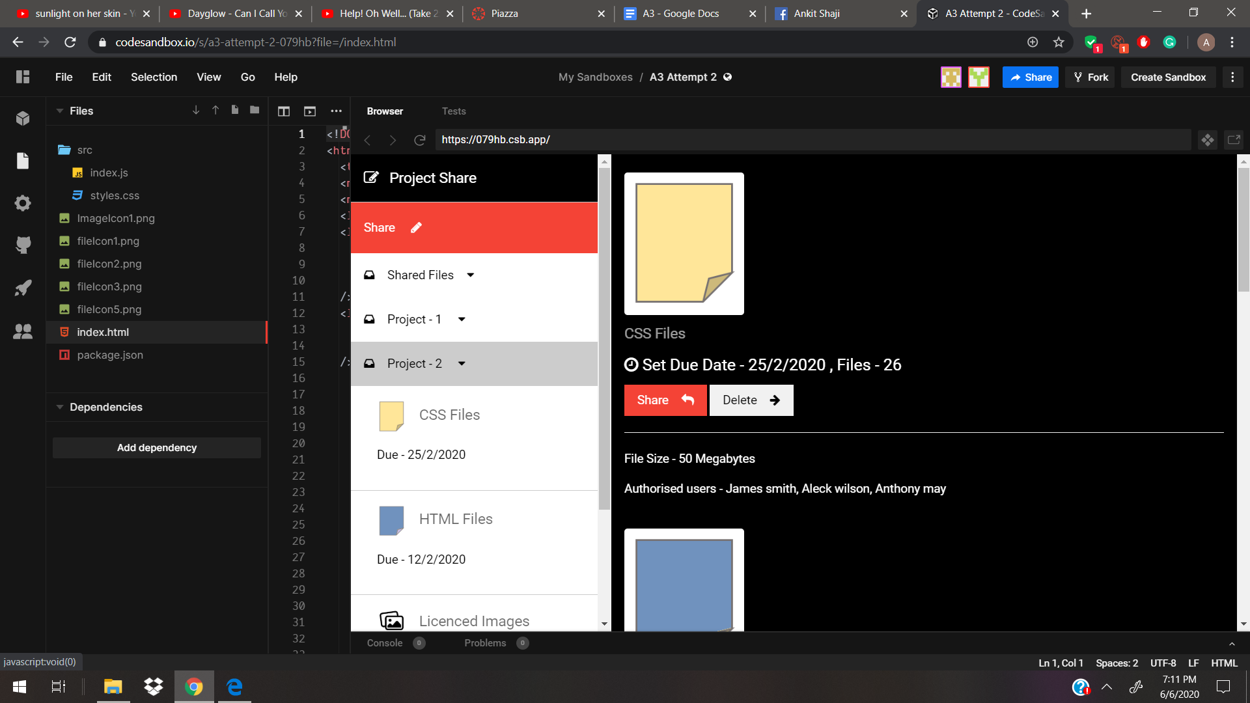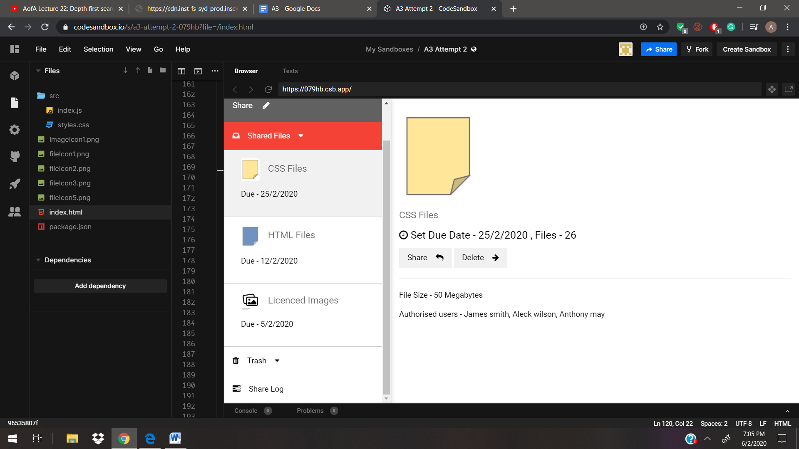

The shared files section Can have multiple projects and each project for a group is divided into different categories of file folder such as css files ,html files and images, that specific group member work on,each section has a set due date that give the member working on that section an awareness of when they need to complete it, thus increasing efficiency of work done.There is also an authorisation for each file that relates to who in the group can edit the files in that section.

We can see that the share and delete are close together to show grouping, thus showing both of them are buttons. We can also see that on the side menu the different folder under the project create a grouping for each project section.The File image and the line at the after the buttons bottom create a group.The background image, since its huge, is seen as the ground while the small images and logos such as buttons and icons are seen as figures.We can see this in the project share and share buttons being visible more than the background structure colours.The conflict between principles can be seen when there is a similar font used in File size and its results and even the Heading font and the text fonts, thus confusing the user. The project share menu also has conflicting principles due to its placement and color choice.

**2.The need for privacy,security and efficiency control -**

**Use Case elaboration -**

The work space must only contain files that are relevant to the project. Therefore any old files that are no longer in use such as drafts or other files that need to be removed can be thrown to the trash. Keeping the project files “clean”, meaning files that are relevant to the project is important so that people viewing it for the first time can work out the files they need to read. With them having a better and clearer understanding of what particular files to read reduces time wasted searching through all the files figuring out which ones are relevant.

We made the trash sidebar option functional. We did this because it is essential for group projects. When you are doing a group project there are many drafts and therefore in order for the main screen to look tidy and not have a whole heap of drafts files must be allowed to be sent to the trash. Also by deleting these unnecessary files you open up more space for files to be stored on the site. For the implementation we added a dropdown to the trash option. We did this so that the user may be able to preview what is in the trash. This will allow users to quickly scroll through what’s in the trash without having to check each file in the trash.

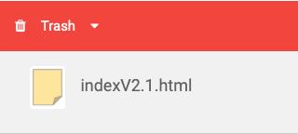

Another feature we added is the vote to delete button on the files in the trash. Five people have to vote for the file to be deleted before it is completely deleted. This will protect against accidental and troll deletions of files. The last we feature we implemented was the time left timer. This indicates to the user how much time they have left to decide whether or not the file will be deleted. If there isn not enough votes once the timer is finished the file returns to where the rest of the files are stored. This is further protection from accidental and troll deletions.

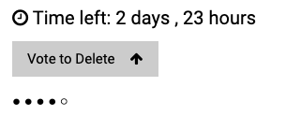

Proximity principle shows that delete button, the file and vote tally are all connected. All the file information such as time left, name, vote button and tally are in line and so the Common Fate principle applies. The file follows the area principle and as of such is noticed as the figure.

**3. The need for visual accountability and file transfer awareness**

**Use Case elaboration -**

When working on an online group project, there is always the difficulty of keeping track of who is doing what, and specifically who has sent what. Without this kind of accountability, there can be a lot of stress over if the workload is being shared equally or if a certain file has been sent. A share log holds people accountable, if a file has been sent/deleted/moved in any way, the share log keeps track and holds users accountable.

We decided to go with the choice of creating a ‘share log’ from which users can see and identify when files have been shared, deleted, or even moved from folder to folder. This is useful for users as it can show where errors in file movement have been made and shows exactly which user did what to the specific file and at what time. This relates to the scenario of student group work specifically due to the importance of holding accountability between members in a group. It provides an easy option for students in this scenario to provide evidence to the university if someone deleted an important file and also provides a clear timeline for when files were shared and by whom. This could be useful for the group to structure their workload, but also for cases where the integrity of a member of the group is brought into question and as such provides evidence to the university for such cases.

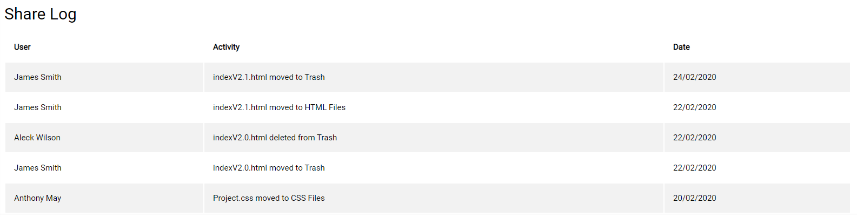

The share log is structured by splitting information into three groups in a table: User, Activity and Date. In a functional share log and in the example given, information would be ordered by date.

In regards to Gestalt principles, the Proximity principle helps differentiate the title from the table and its contents. The Similarity principle is applied to the table by the colour pattern identifying the table as one unit. The Common Fate principle shows that the information under the subheadings are related(names under ‘user’, etc). The Closure principle identifies the table as although the table doesn’t have actual borders, we can clearly see where it is defined. Pragnanz principle helps support the Closure principle in identifying the table as a defined structure.

**Link to video -** <https://www.youtube.com/watch?v=KQaAcDC79-o>

**Protocol Description -**

**1.Greeting script**

We asked participants to write down problems they encountered to fix them for future users. We chose 60 minutes as the time as we believe this is more than enough time to fully analyse the site and all that it offers. We give feedback to the user so that they know that the problem they identified has been dealt with and how. We let the user sign a consent form and explain their privacy right so that they are aware that this is a study and will not in any way affect their own privacy. Finally we say let’s get started to indicate to the user it is time for them to view the site.

**2.Informed consent form**

The consent form chosen was from the referenced UX textbook which is the book used in the CS345 course. We chose this due to its simplicity and that it informs the user on what is required of them and what they are allowed to do.

**3.Hypotheses, tasks and prompts**

We choose these Hypotheses since they related to the potential issue we thought users would have while using the website. These Hypotheses and tasks relate to our use cases and design choices. The tasks were based on ways on how we would be able to test the hypothesis. The prompts were used so the user might give us clear feedback on each particular hypothesis as well to make sure we do all we can to get some useful information.

**4. Metrics**

All metrics were chosen because they related to the goals of creating Project Share. Specifically, our first UX goal, ease of use, related to the share function and the time to completion. This is important as it shows how long it takes for the user to comprehend the feature and subsequently fill out the share feature and successfully ‘share’ the file. Times for baseline and target levels were chosen based off individual team members testing the feature and then giving +5 seconds to the target level, and +20 seconds to the baseline to account for new users not being as fluent with this technology as us.

The second UX goal was ‘user satisfaction’, this was measured via a series of likert scale questions, baseline level was satisfied and target level very satisfied as it we wanted users to enjoy/value our system, not be neutral to it, so these values were a natural progression of a 5 part likert scale, from very unsatisfied to very satisfied. The questions were chosen based on their relation to features we added to ‘Project Share’ such as the share feature, trash feature, file feature, share log, aesthetics and then an overall view of ‘Project Share’.

**Test Results:**

**Person 1:**

Raw Data:

For Test 1, the user had a good understanding of the functionality of the website. He could easily identify what features did generally and could navigate the site without assistance, only need prompting for certain things. He needed prompting for the Share Log and did not understand the purpose of it without it being explained(asked “what’s it for”). This could suggest the Share Log’s purpose is not easily identifiable or valued. However, with the Due date feature, he immediately understood the value of it when questioned. There was also confusion regarding the tally of votes for ‘vote to delete’, so it’s possible a more easily understood feature could be used to explain the current vote count to users. He also didn’t understand initially what the ‘time left’ in the Trash tab did, so perhaps something could be done here to make it more clear how the voting/deletion system works.

Metrics:

He did not make the connection between the colour scheme for this site and canvas, but he did appreciate the aesthetic despite that, giving it a ‘Very satisfied’ on a likert scale, and calling the colour scheme ‘simple and effective’. Overall, we can consider the aesthetic of the site to be a success for this user. He was ‘satisfied’ on a likert scale for the success popup for sharing, suggesting that this wasn’t that important to him, but he still was happy with it (definitely no negative reaction). He was ‘satisfied’ for both the trash feature and the share log, but ‘Very satisfied’ for the file feature. This suggestions from both his comments earlier and these results that the concerns he raised in the Raw Data were important enough to not give a ‘Very satisfied’ result for these two features. For the site as a whole, the user gave it a ‘Very Satisfied’, which achieved our target level for this user. User took 12 seconds to share a file, was is 3 seconds faster than our target level, so for this user we can consider the share feature to be easily understandable and successful. Overall, we can consider the site to be success for our target metrics, some thought should be given to the success popup however, as it only achieved our baseline level.

**Person 2:**

Raw Data:

The user did not identify what the beads were and that they were meant to signify how many people had voted to delete the file. This means that we need to make it more obvious for users possibly by adding text next to it explaining what it is. The user thought that the due date feature was “cool” and therefore reinforces what a good idea that was to include. The user being able to successfully use the share feature is a good sign that the placement and implementation of the website has been done properly and is easily understood. The user also found the share log to be useful and also reinforces what a good idea that was to implement.

Metrics:

The user took longer to share a file than the participant for test 1 however it was stated that the user spent time thinking about what to write. So I don’t believe the extra time is because of any website issues but that it is a better representation of how long it would normally take for someone to do it since they will have to think and write what file to share. The user also enjoyed the share log and was very satisfied with it meaning we could improve it more and enhance it since it may be a feature most users will use. The trash file needs work as evident in the user not knowing what some of the components were however overall the user was satisfied with it so no major changes are needed. Finally the user was satisfied with the aesthetics and noticed a lot of features that they saw as useful or cool and therefore means the overall aesthetic of the website is at a good level and doesn’t need much changing.

**Implications-**

Looking at the results from both participants we can see that for h1 neither of the users were able to the immediately recognized the color scheme connection to canvas, this lets us know that the users either subconsciously were aware due to it being a university related website or the users did not relate the color to canvas at all, the ideal thing to do here is to conduct more tests and if we get consistent negative results we would have to alter the color and icons of the website until it is recognizable.We see that both users did not have issues with the navigation of the website, thus letting us know out navigation foundation is strong therefore it does not need to be altered. Looking at the results for the reaction to the pop up we can see one user found the success message to be appealing while the other saw it as either being a website standard or as a potential annoyance, Therefore we need to do more tests on users to see what type of people appreciate these pop ups and if these people are the higher majority of our websites users. We can see there were other small issues that need to be fixed, such as, both the users found the vote tally structure to not be understandable at first glance, thus after more testing we could come to the conclusion to change it.

**References**

Hartson & Pyla. (2019). The UX Book: Agile U

Hartson & Pyla. (2019). The UX Book: Agile UX design for a quality user experience.Morgan Kaufmann.

NB: Appendix on next page.

**Appendix**

**Test Protocol**

**Greeting Script**

Hi user I’m Marion with group 80. This project is about making a file sharing system website for Auckland University students to use for their group projects. We added features to this website such as the updated trash system, share log and shared files option. We are looking to enhance the user experience for all those that use this website. Please provide feedback to us if you have any problems with the website so we may be able to fix these problems.

Please list all problems you see in the site and write down all your thoughts as you go through the website so we can understand the choices you make. The study will take around 60 minutes and we’ll answer your questions at the end of the study.

First we’ll need you to sign this Consent Form. It is important to mention that the information gathered from today will only be used for research purposes. And should this study be published all participant references will be done anonymously. We aim to keep your privacy.

Do you have any questions?

Let’s get started.

**Informed Consent Form**

Simple Informed Consent Form

Informed Consent for Participant of Development Project

Group 80 CS345

Title of Project: Assignment 3: Hi-fi Prototype and Usage Testing

Project team member(s) directly involved: Ankit, Clinton and Marion

Project manager: n/a

I.THE PURPOSE OF YOUR PARTICIPATION IN THIS PROJECT

As part of the Assignment 3: Hi-fi Prototype and Usage Testing project, you are invited to participate in evaluating and improving various designs of **Project Share**, a website prototype based around improving the experience of users for sharing files.

II.PROCEDURES

You may be asked to perform a set of tasks using **Project Share**. These tasks consist of finding certain features or opening up certain menus, however we may just let you do unsupervised exploring of **Project Share**.

Your role in these tests is to help us evaluate the designs.We are not evaluating you

Or your performance in any way. As you perform various tasks with the system,your

Actions and comments will be noted and you will be asked to describe verbally your

learning process. You may be asked questions during and after the evaluation in

Order to clarify our understanding of your evaluation.You may also be asked to fill

out a questionnaire relating to your usage of the system.

The evaluation session will last no more than four hours, with the typical

Session being about two hours.The tasks are not very tiring,but you are welcome

to take rest breaks as needed. If you prefer, the session may be divided into two

shorter sessions.

III. RISKS

There are no known risks to the participants of this study.

IV. BENEFITS OF THIS PROJECT

Your participation in this project will provide information that may be used to improve our designs for **Project Share**.

No guarantee of further benefits has been made to encourage you to

Participate.

You are requested to refrain from discussing the evaluation with other people who might

be in the candidate pool from which other participants might be drawn.

V. EXTENT OF ANONYMITY AND CONFIDENTIALITY

The results of this study will be kept strictly confidential. Your written consent is required for the researchers to release any data identified with you as an individual to anyone other than personnel working on the project. The information you provide will have your name removed and only a subject number will identify you during analyses and any written reports of the research. The session may be recorded. If it is recorded, the recordings will be stored securely, viewed only by the project team members and erased after three months. If the project team members wish to use a portion of your recording for any other purpose, they will get your written permission before using it. Your signature on this form does not give them permission to show your recording to anyone else.

VI. COMPENSATION

Your participation is voluntary and unpaid.

VII. FREEDOM TO WITHDRAW

You are free to withdraw from this study at any time for any reason.

VIII. APPROVAL OF RESEARCH This research has been approved by the UoA Computer Science faculty.

IX. PARTICIPANT RESPONSIBILITIES AND PERMISSION

I voluntarily agree to participate in this study, and I know of no reason I cannot participate. I have read and understand the informed consent and conditions of this project. I have had all my questions answered. I hereby acknowledge the above and give my voluntary consent for participation in this project. If I participate, I may withdraw at any time without penalty.I agree to abide by the rules of this project.

Signature Date

Name (**please print**) Contact: phone or email

**Hypotheses, Tasks and Prompts**

**Hypothesis 1** - User may not recognize the canvas color scheme relation

**Task** – Look at the website, get first impression

**Prompt**  [if user doesn't naturalistically say] “What does the color scheme remind you of”

**Hypothesis 2** - Users will be able to navigate the website without confusion.

**Task** - Find html files in project 2 folder, get their impression

**Prompt**  “Can you find the html files for project 2”

**Hypothesis 3** - User will value the success popup after sharing a file

**Task** - Use the share function, get their impression

**Prompt**  [if user doesn't naturalistically explore] “ Tell me what you think about the share function.”

**Type(s) of metric(s) or observations to be recorded**

|  |  |  |  |  |  |  |  |
| --- | --- | --- | --- | --- | --- | --- | --- |
| **Work Role: User Class** | **UX Goal** | **UX Measure** | **Measuring Instrument** | **UX Metric** | **Baseline Level** | **Target Level** | **Observed results** |
| **Casual New User - File sharer** | **Ease of use** | **Initial performance** | **Share a file** | **Average time to task completion** | **0:30** | **0:15** | **(seen in results)** |
| **Casual New User - File sharer** | **User**  **satisfaction** | **First impression** | **Questions** | **Rating across questions** | **Satisfied** | **Very Satisfied** | **(seen in results)** |

**Likert scale questions:**

Very Unsatisfied Unsatisfied Neutral Satisfied Very Satisfied

Question 1: How satisfied were you with the success popup after sharing a file?

Question 2: How satisfied were you with the trash feature?

Question 3: How satisfied were you with the file features?

Question 4: How satisfied were you with the share log?

Question 5: How satisfied were you with the aesthetics of Project Share?

Question 6: How satisfied were you with Project Share?

**Raw Observations**

**Person 1:**

**Raw Data:**

User immediately entered the Share function and filled out the form successfully.

'Cute' reponse to the success message(was noticed/appreciated).

Made of the highlighting for hovering over icons(especially noticed consistent 'green' for share hovering.

Had to be prompted to look at Share Log, asked "what's it for", so doesn't see the usefulness

initially.

When asked of the design said "simple and effective", didn't notice the colour scheme being similar to canvas.

Had to be asked about the Due Date feature, ‘ah, that would be helpful’, so immediately noticed its usefulness.

Did not recognise the icons below ‘vote to delete’ button were a tally of the votes done so far, did ask ‘what happens when the time left runs out?’, so noted the feature, but didn’t understand its purpose.

Was able to navigate the website without assistance. When prompted to find html files in Project 2, they had no issues.

**Metrics**:

Took User 12 seconds to ‘share’ a file from entering the feature.

Was ‘Satisfied’ with the success popup for sharing.

Was ‘Satisfied’ with the trash feature.

Was ‘Very Satisfied’ with the file feature.

Was ‘Satisfied’ with the share log.

Was ‘Very Satisfied’ with the aesthetics.

Was ‘Very Satisfied’ with Project Share.

**Person 2:**

**Raw Data:**

User immediately clicked through all the files, trash, share log. Noted the Green hover for share in file section and for Share feature.

Noticed the Due date feature, ‘cool that it’s there, can it be edited?’.

Successfully filled out Share feature(wasted time being unsure of what message to write), no comment on ‘Success’ message, just X’ed out.

Noted the blue colour scheme for the side navigation, but didn’t find the comparison to canvas without prompting ‘Ohh!’.

Had to be prompted back to the trash feature, asked ‘what the beads were’ for the vote feature, so again did not know it was a tally. Found the idea of a group vote system for file deletion ‘cool’.

Found the share log ‘useful for tracking when files are shared’, so saw the value in the feature.

Was able to navigate the site successfully(understood what each button did). When prompted to find html files for Project 2, he had no issues.

**Metrics:**

Took User 27 seconds to ‘share’ a file from entering the feature.

Was ‘Satisfied’ with the success popup for sharing.

Was ‘Satisfied’ with the trash feature.

Was ‘Very Satisfied’ with the file feature.

Was ‘Very Satisfied’ with the share log.

Was ‘Satisfied’ with the aesthetics.

Was ‘Satisfied’ with Project Share.